**NAME**: - Jaydeep Solanki

**ROLL NO**: - 22ECG060 | 22BEC059

**COURSE CODE**: - 1CS501

**SUBJECT**: - COMPUTER PROGRAMMING

**PRACTICAL NO 4:** C programs to demonstrate use of loop constructs



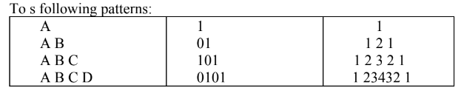

**Code :**

#include <stdio.h>

int main() {

for (int i = 0; i < 4; i++) {

char a = 'A';

for (int j = 0; j <= i; j++) {

printf("%c", a);

a++;

}

printf("\n");

}

printf("\n");

for (int i = 0; i < 4; i++) {

int sum;

for (int j = 0; j <= i; j++) {

sum = i + j;

if (sum % 2 == 0) {

printf("1");

} else {

printf("0");

}

}

printf("\n");

}

printf("\n");

for (int i = 1; i < 5; i++) {

int n = 5;

for (int k = 1; k < n - i; k++) {

printf(" ");

}

for (int j = 1; j <= i; j++) {

printf("%d", j);

}

for (int l = i - 1; l > 0; l--) {

printf("%d", l);

}

printf("\n");

}

return 0;

}

**Output:**

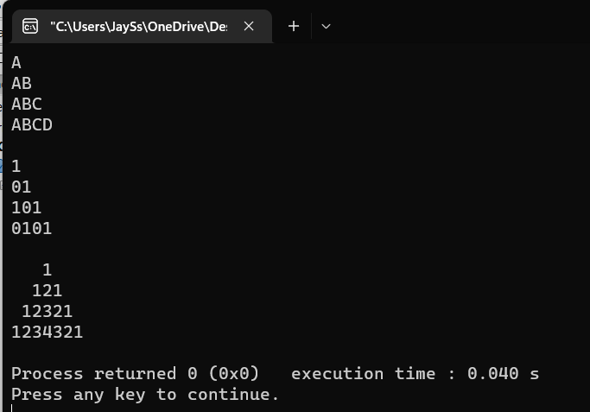

1. To determine whether the input number is an Armstrong number

**Code:**

#include<stdio.h>

int main()

{

int num1,num2=0,num3,num4;

printf("Number to check: ");

scanf("%d",&num1);

num3=num1;

while(num1>0)

{

num4=num1%10;

num2+=(num4*num4*num4);

num1=num1/10;

}

if(num3==num2)

{

printf("Number is Armstrong number...!\n");

}

else

{

printf("Number is not a Armstrong number...!\n ");

}

return 0;

}

**Output:**

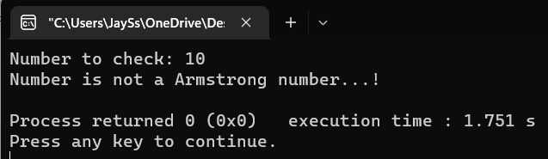

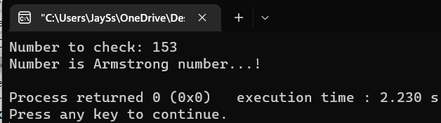

1. To determine whether the entered number is Prime

**Code:**

#include <stdio.h>

int main() {

int number_to_ck, num2, temp_num = 0;

printf("Number to check: ");

scanf("%d", &number_to_ck);

num2 = number_to_ck / 2;

for (int i = 2; i <= num2; i++) {

if (number_to_ck % i == 0) {

printf("Not a prime number.");

temp_num = 1;

break;

}

}

if (temp_num == 0) {

printf("Number is prime.");

}

return 0;

}

**Output:**

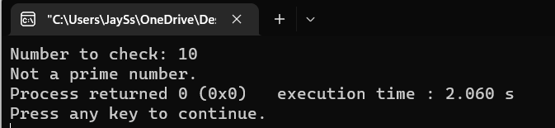

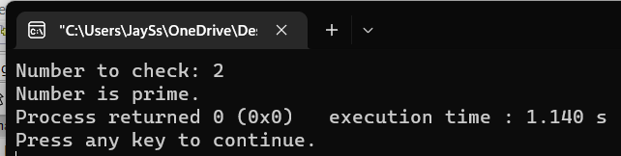

1. To determine whether the entered number is Palindrome.

**Code:**

#include <stdio.h>

int main() {

int number, rem, original_number, reverse = 0;

printf("Enter the number: ");

scanf("%d", &number);

original_number = number;

while (number != 0) {

rem = number % 10;

reverse = reverse * 10+rem;

number /= 10;

}

printf("The reversed number is %d\n", reverse);

if (original_number == reverse) {

printf("The number is a Palindrome.");

} else {

printf("The number is not a Palindrome.");

}

return 0;

}

**Output:**

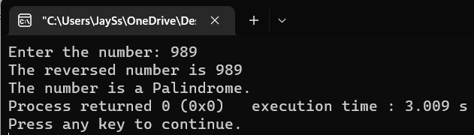

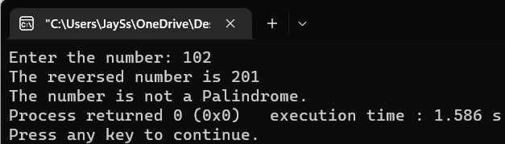

1. Enhance the number guessing game developed earlier. The program should now display more appropriate message (Greater, Smaller or Correct). It should allow maximum 5 attempts from the user and still if the user cannot guess the number correctly, it should display “Sorry”.

**Code:**

#include <math.h>

#include <stdio.h>

int main() {

int guess, tries = 0;

srand(time(NULL));

int num = rand() % 100;

printf("====Number Guessing Game====\n\n");

for (int i = 1; i <= 5; i++) {

printf("Enter a guess number between 1 to 100 : ");

scanf("%d", &guess);

tries++;

if (guess > num) {

printf("Please guess smaller number.\n\n");

} else if (guess < num) {

printf("Please guess greater number.\n\n");

} else {

printf("\nCongratulations!\nYou got it in %d guesses,\n", tries);

}

}

if (guess != num) {

printf("Sorry..!\nBetter luck next time..!");

printf("The number was : %d\n", num);

}

return 0;

}

**Output:**

